The Annual Parish Meeting of Grandborough
Will be held in the Village Hall
On Tuesday 5th May 2026 at 18.30 hrs

Agenda
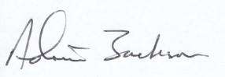
A Jackson
Chair of Grandborough Parish Council
5th April 2026

- Apologies for absence
- To approve minutes of the last meeting held on 6th May 2025
- Matters arising from the meeting
- Report from Borough Councillor
- Report from Warwickshire County Councillor
- Reports from other bodies (if any)
- Report by the Chair of the Parish Council
- Open Forum

